CS-19 SECURITY AWARENESS QUIZ/GAME
Cybersecurity Capstone Project Report

Table of Contents
- Executive Summary
- Assessment Report
2.1 Purpose and Scope
2.2 Problem Statement
2.3 Project Objectives
2.4 Methodology
2.5 Question Bank Architecture
2.6 Game Features and User Experience
2.7 Scoring Model
2.8 Sample Assessment Outcomes
2.9 Admin and Reporting Capabilities
2.10 Limitations and Assumptions
- Safe-Lab Evidence Statement
3.1 Lab Usage Determination: Not Required
3.2 Rationale
3.3 Evidence Artifacts Produced
3.4 Safe Testing Performed
- Remediation and Security Awareness Recommendations
4.1 Phishing Prevention
4.2 Social Engineering Awareness
4.3 Password and Account Security
4.4 Safe Email and Link Handling
4.5 Incident Reporting and Escalation
4.6 Continuous Security Awareness Training
4.7 Application Security and Hardening
- Conclusion
- Walkthrough Video Guide
- Appendices
7.1 Technology Stack
7.2 Project Directory Structure
7.3 Running the Project
7.4 Screenshots and Evidence
7.5 Sample Questions

1. Executive Summary
Cybersecurity incidents within organizations are not caused solely by technical vulnerabilities. Employees and other users can also become an entry point for cyberattacks when they are unable to recognize phishing messages, suspicious links, social engineering attempts, weak security practices, or other common threats.
This project developed an interactive Security Awareness Quiz/Game designed to assess and improve users' understanding of common cybersecurity risks. Rather than relying solely on traditional security-awareness training materials, the project uses an interactive assessment format to make cybersecurity education more engaging and practical.
The application was developed as a local web-based application using Python and Flask, with interactive quiz functionality accessible through a standard web browser. The system provides users with security-awareness questions and interactive activities designed to test their ability to identify and respond appropriately to common cyber threats.
Key features include a general security-awareness quiz, a Spot the Phish activity that allows users to identify suspicious elements within phishing scenarios, automated scoring, and an administrative interface for managing assessment content.
The project was tested locally to verify its functionality, navigation, question handling, answer evaluation, scoring, and administrative features. Because the project is an educational awareness application and does not require exploitation of live systems, malware execution, vulnerability exploitation, or offensive security operations, a separate safe-lab environment was not required.
The completed application demonstrates how security awareness can be delivered through an interactive platform that provides users with immediate assessment and feedback. The project can serve as a foundation for future organizational security-awareness programs, particularly those focused on phishing and social-engineering prevention.

2. Assessment Report
2.1 Purpose and Scope
The purpose of this project is to develop an interactive cybersecurity awareness tool that can be used to assess users' knowledge of common security threats and encourage safer behavior when interacting with digital systems.
The project focuses primarily on human-centered cybersecurity risks, particularly those associated with phishing, social engineering, suspicious links, account security, and unsafe online behavior.
The scope of the project includes:
- Development of a browser-based security-awareness application.
- Creation of cybersecurity awareness questions and scenarios.
- Implementation of interactive assessment modes.
- Development of a Spot the Phish activity.
- Automated evaluation of user responses.
- Calculation and display of assessment scores.
- Development of an administrative interface for managing questions.
- Local functional testing of the application.
The project does not attempt to replace enterprise security controls, penetration testing, vulnerability assessments, security monitoring systems, or formal cybersecurity training programs.

2.2 Problem Statement
Employees are frequently targeted by cyberattacks that rely on human interaction rather than sophisticated technical exploitation. Phishing emails, malicious links, impersonation, fraudulent requests, and other social-engineering techniques can be effective when users are unable to recognize warning signs.
Traditional cybersecurity awareness training may also become repetitive or passive when it relies primarily on presentations, documents, or lectures. This can make it difficult to determine whether users can apply what they have learned when presented with realistic security situations.
There is therefore a need for an engaging assessment approach that allows users to actively demonstrate their cybersecurity knowledge rather than simply receiving information.
This project addresses this problem by providing an interactive security-awareness quiz/game through which users can test their ability to identify common cyber threats and make appropriate security decisions.

2.3 Project Objectives
The main objective of the project is to develop an interactive security-awareness assessment tool that improves user engagement while testing knowledge of common cybersecurity threats.
The specific objectives are to:
- Develop a functional browser-based cybersecurity awareness application.
- Assess users' knowledge of common cybersecurity risks.
- Help users recognize phishing and social-engineering indicators.
- Provide interactive security-awareness activities rather than relying solely on passive learning.
- Implement automated scoring of user responses.
- Provide immediate assessment results to users.
- Provide an administrative interface for managing assessment questions.
- Test the functionality and usability of the completed application.
- Provide recommendations for improving organizational security awareness based on the risks addressed by the application.

2.4 Methodology
The project followed an application-development and functional-testing approach.
The development process involved identifying common cybersecurity awareness risks, designing questions and scenarios around those risks, implementing the application, testing individual features, and reviewing the user experience.
Phase 1: Requirement Identification
Common human-related cybersecurity risks were identified as the primary focus of the application. These included phishing, suspicious links, social engineering, password security, and unsafe user behavior.
Phase 2: Question and Scenario Development
Questions were designed to assess whether users could distinguish between safe and unsafe cybersecurity practices.
Interactive scenarios were also incorporated to make the assessment more practical. Particular emphasis was placed on phishing recognition through the Spot the Phish activity.
Phase 3: Application Development
The application was implemented as a local web application using Python and the Flask framework. The browser-based design allows users to interact with the application without requiring a separate desktop application.
Phase 4: Feature Implementation
The major assessment features were implemented, including:
- Standard security-awareness questions
- Spot the Phish
- Answer evaluation
- Score calculation
- Results display
- Administrative question management
Phase 5: Functional Testing
The completed application was tested locally to confirm that users could navigate through the assessment, submit answers, receive appropriate results, and complete the available activities.
Administrative functionality was also tested to confirm that questions could be managed through the administrative interface.

2.5 Question Bank Architecture
The question bank forms the core of the assessment system. Questions are structured around common cybersecurity awareness topics and are presented through different assessment formats.
The question categories include areas such as:
- Phishing awareness
- Suspicious links and websites
- Social engineering
- Password and account security
- Safe handling of emails and messages
- General cybersecurity behavior
The application uses different question formats to reduce repetition and make the assessment more engaging.
Standard Quiz- Cyber Challenge Mode
The standard quiz presents cybersecurity questions to the user and evaluates their selected responses through multiple-choice workplace scenarios across these topics:
- Phishing and email security
- Passwords and multi-factor authentication
- Social engineering
- Device and USB security
- Data protection and safe browsing
The seeded question bank contains 25 general challenge questions, while each attempt presents ten questions. Each question has four options, one correct answer, an explanation, and a difficulty level.

Spot the Phish mode
Spot the Phish is an interactive activity designed to test whether a user can recognize indicators of a phishing attempt. It presents ten simulated messages from email, SMS, or WhatsApp. Instead of using ordinary multiple choice, the user selects the message zone containing the strongest warning sign, such as a lookalike sender domain, an urgent credential request, a suspicious executable file, or a request to bypass physical access controls
Rather than simply asking the user to select "phishing" or "not phishing," the activity focuses attention on specific elements of a suspicious communication. This approach encourages users to examine details such as links, sender information, wording, requests for information, and other warning signs.

2.6 Game Features and User Experience
The application was designed to make cybersecurity awareness more interactive and less dependent on traditional training formats.
Interactive Assessment
Users interact directly with the application and submit responses to cybersecurity questions.
Spot the Phish
The Spot the Phish feature provides a practical way for users to identify suspicious elements in phishing scenarios.
Automated Feedback
The application evaluates responses and provides the user with an assessment outcome.
Score Display
Users receive a score based on their performance during the assessment.
Administrative Interface
An administrative section allows authorized users to manage assessment questions and content.

2.7 Scoring Model
The scoring system is designed to provide a simple indication of how well a user performed during the assessment.
A user's score is determined by the number of correctly answered questions relative to the total number of questions attempted.
The basic calculation is:
Score (%) = (Number of Correct Answers ÷ Total Questions) × 100
For example, if a user answers 8 out of 10 questions correctly:
Score = (8 ÷ 10) × 100 = 80%
The resulting score provides a simple measure of the user's demonstrated cybersecurity awareness during the assessment.
The scoring model can be expanded in future versions to include topic-specific scores, difficulty weighting, completion time, and risk-based performance categories.

2.8 Sample Assessment Outcomes
The assessment produces a result based on the user's performance.
Possible outcomes include:
- High performance, indicating strong understanding of the assessed security concepts.
- Moderate performance, indicating areas where additional awareness training may be beneficial.
- Low performance, indicating a need for further cybersecurity awareness education.
The results should be interpreted as an indication of performance within the assessment and should not be treated as a complete measurement of an individual's overall cybersecurity competence.
Screenshots of the completed application's results interface will be included in Appendix D as evidence of the implemented functionality.

2.9 Admin and Reporting Capabilities
The application includes an administrative interface that allows assessment content to be managed.
Administrative functionality includes the ability to:
- Access the question-management interface
- Review existing questions
- Add or modify assessment questions
- Manage question content used by the assessment
This functionality allows the question bank to be updated without requiring the entire application to be rebuilt.
In a future organizational deployment, the administrative interface could be expanded to include user performance dashboards, topic-level reporting, historical results, user management, and exportable reports.

2.10 Limitations and Assumptions
The project has several limitations.
First, the application was developed as a capstone prototype and was tested in a local environment rather than deployed as a production enterprise system.
Second, the assessment focuses on selected cybersecurity awareness topics and therefore does not represent every possible cybersecurity threat.
Third, the accuracy of the assessment depends on the quality and relevance of the questions included in the question bank.
Fourth, the current scoring system provides an overall performance indication but does not provide comprehensive behavioral analysis.
Finally, the administrative interface would require additional authentication, authorization, logging, and security controls before being deployed in a real organizational environment.

3. Safe-Lab Evidence Statement
3.1 Lab Usage Determination: Not Required
A dedicated cybersecurity safe-lab environment was not required for this project.
3.2 Rationale
The project is a security-awareness quiz/game rather than an offensive-security or vulnerability-exploitation project.
The application does not require:
- Exploitation of live systems
- Malware execution
- Vulnerability exploitation
- Credential attacks
- Network attacks against external systems
- Penetration testing
- Interaction with production infrastructure
The phishing examples used within the application are simulated educational scenarios intended to teach users how to recognize suspicious communications.
Development and functional testing were performed locally using controlled application data. As a result, the project did not require the type of isolated laboratory environment normally needed for projects involving potentially harmful security activities.
3.3 Evidence Artifacts Produced
Although a dedicated safe lab was not required, evidence of the project's development and testing was produced.
The evidence includes:
- Screenshots of the completed application
- Screenshots of the assessment interface
- Evidence of the Spot the Phish feature
- Evidence of scoring and assessment results
- Evidence of the administrative interface
- Walkthrough video demonstrating the application
These artifacts demonstrate the functionality of the completed project without requiring potentially harmful security testing.
3.4 Safe Testing Performed
Functional testing was performed within the local application environment.
Testing focused on:
- Application loading and navigation
- Question presentation
- Answer selection
- Correct and incorrect response handling
- Score calculation
- Results display
- Interactive assessment features
- Administrative question management
No testing was performed against external systems or infrastructure.

4. Remediation and Security Awareness Recommendations
4.1 Phishing Prevention
Organizations should provide regular phishing-awareness training that teaches employees to identify suspicious senders, unusual requests, misleading links, unexpected attachments, and attempts to create urgency.
Users should be encouraged to verify unusual requests through trusted communication channels rather than responding immediately.
4.2 Social Engineering Awareness
Security awareness programs should address social-engineering techniques such as impersonation, urgency, authority manipulation, and requests for confidential information.
Employees should understand that attackers may manipulate human behavior rather than relying solely on technical vulnerabilities.
4.3 Password and Account Security
Users should be encouraged to use strong, unique passwords and enable multi-factor authentication where available.
Organizations should also provide clear guidance on password sharing, credential protection, and account-security procedures.
4.4 Safe Email and Link Handling
Employees should avoid clicking unexpected links or opening suspicious attachments.
Users should learn to inspect URLs carefully and verify the legitimacy of websites before entering credentials or sensitive information.
4.5 Incident Reporting and Escalation
Organizations should establish simple procedures for reporting suspected phishing and other security incidents.
Employees should know:
- What to report
- Who to report it to
- How quickly to report it
- What actions to take after interacting with a suspicious message
Early reporting can reduce the potential impact of a security incident.
4.6 Continuous Security Awareness Training
Cybersecurity awareness should not be treated as a one-time activity.
Organizations should conduct periodic awareness assessments and refresher training. Interactive tools such as the Security Awareness Quiz/Game can be incorporated into these programs to assess knowledge over time.
4.7 Application Security and Hardening
Before the application is deployed beyond a local prototype, additional security controls should be implemented.
These should include:
- Secure administrator authentication
- Role-based access control
- Password hashing and secure credential management
- Input validation
- Protection against common web application vulnerabilities
- Secure session management
- Audit logging
- Secure configuration of the production environment
- Regular dependency updates
- HTTPS for production deployment

5. Conclusion
The Security Awareness Quiz/Game demonstrates how cybersecurity education can be transformed into a more interactive assessment experience.
The project addresses a significant area of cybersecurity risk: human behavior. Through features such as the standard quiz, Spot the Phish, automated scoring, and administrative question management, the application provides a practical way to assess users' understanding of common cybersecurity threats.
Functional testing confirmed the operation of the major application features within the local environment. The project did not require a dedicated safe-lab environment because it did not involve offensive security activities, exploitation, malware, or testing against external systems.
Although the current application is a prototype, it provides a foundation that could be expanded into a broader organizational security-awareness platform. Future development could include user accounts, performance dashboards, topic-specific analytics, timed assessments, question difficulty levels, phishing simulations, and persistent reporting.
Overall, the project demonstrates that cybersecurity awareness training can be made more engaging while still providing measurable assessment outcomes.

6. Walkthrough Video Guide
The walkthrough video will provide a short demonstration of the completed application and its major features.
The demonstration will include:
- Opening the application
- Introducing the purpose of the Security Awareness Quiz/Game
- Demonstrating the standard quiz
- Demonstrating the Spot the Phish activity
- Showing the scoring/results functionality
- Briefly demonstrating the administrative interface
- Concluding with the purpose and potential organizational use of the application
The final walkthrough video will be approximately 2–3 minutes in length

7. Appendices
Appendix A — Technology Stack
The project was developed using:
- Python — primary programming language.
- Flask — web application framework.
- SQLite — local database for application data.
- HTML/CSS — user interface structure and presentation.
- JavaScript — interactive client-side functionality where applicable.
- Web Browser — used to access and test the application locally.
- Windows — development environment.
Appendix B — Project Directory Structure
The final directory structure will be documented here using a screenshot or text representation of the actual project files.
├── app.py
├── PROJECT_MAP.txt
├── README.md
├── requirements.txt
├── setup.bat
├── start.bat
├── cyberready.db
├── static/
│ └── css/
│ └── style.css
└── templates/
├── admin_login.html
├── admin.html
├── edit_question.html
├── feedback.html
├── index.html
├── quiz.html
└── result.html

Appendix C — Running the Project
The application can be run locally by starting the Flask application and accessing the provided local address through a web browser.
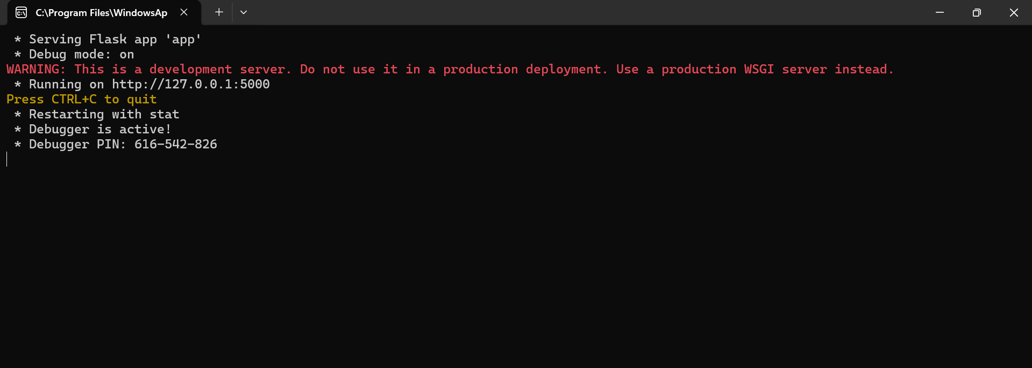
Appendix D — Screenshots and Evidence
This section will contain screenshots of:
- Application landing page.
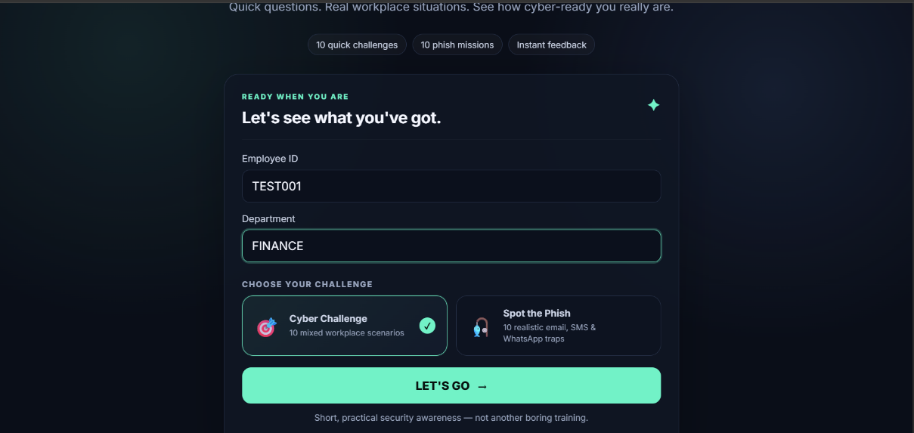
- Standard quiz.
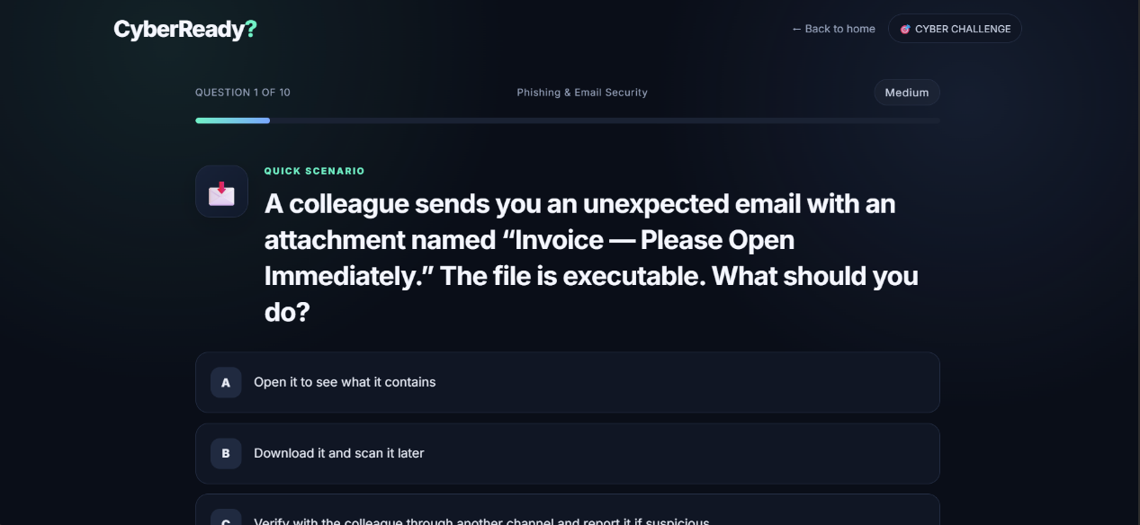
- Spot the Phish activity.
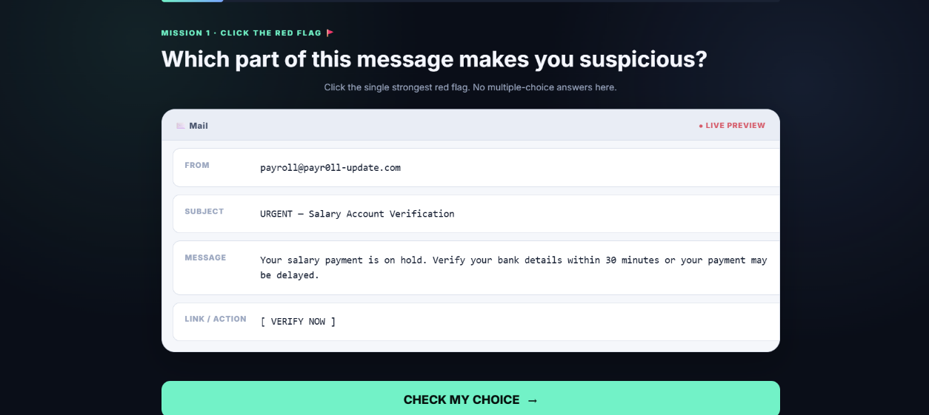
- Assessment results.
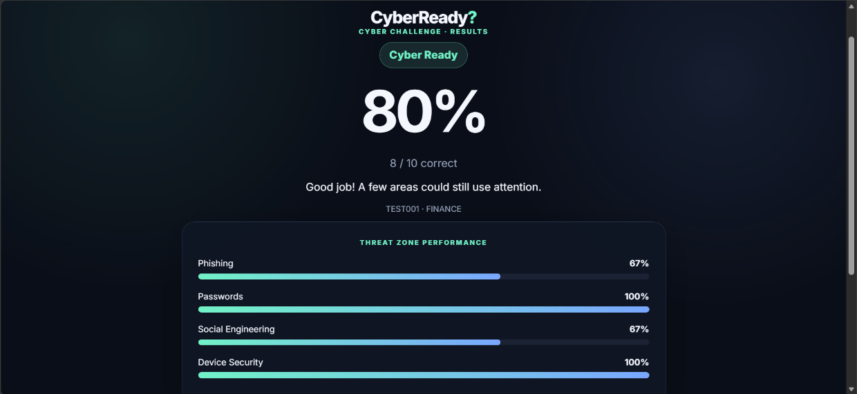
- Administrative interface.
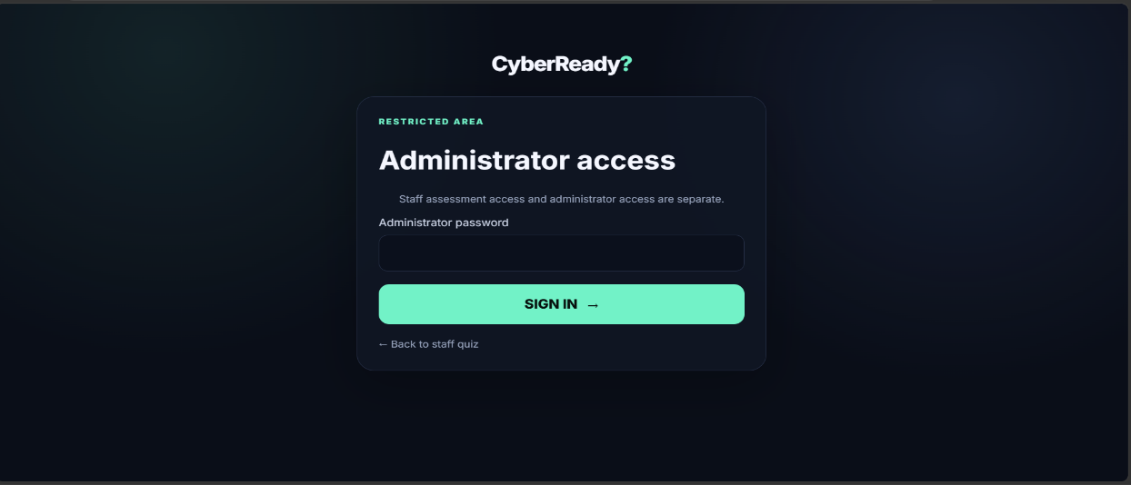

- Question-management interface.
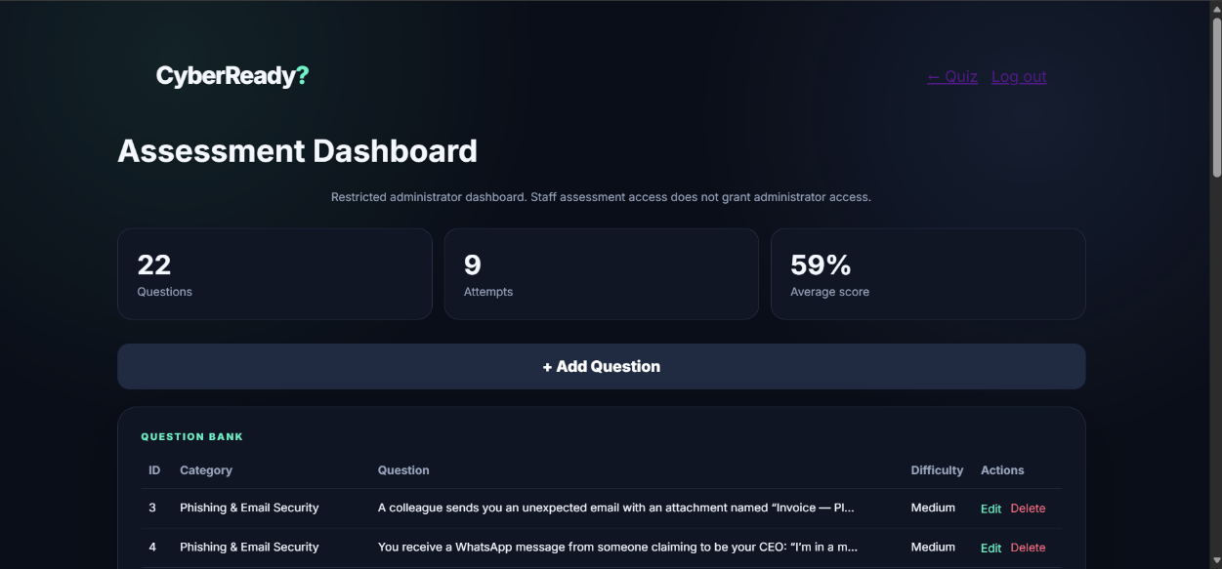
- User-summary interface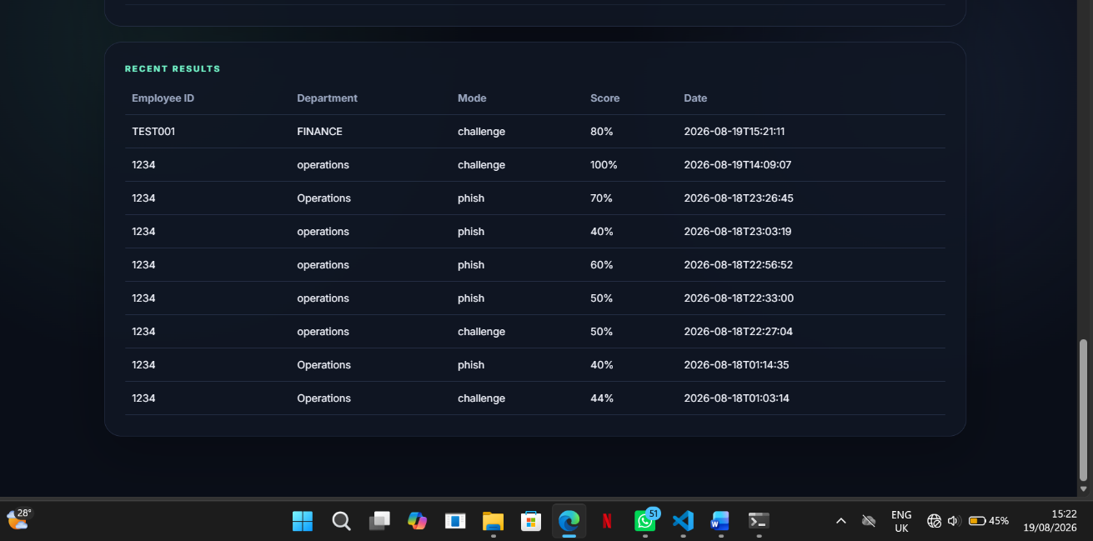

Appendix E — Sample Questions
Selected questions from the implemented question bank will be included to demonstrate the types of cybersecurity awareness concepts assessed by the application.
Awareness Concept | Example Assessment Scenario
Phishing | An employee receives an urgent salary verification email containing a link.
Password Security | An employee uses the same password for their work email and a personal account.
MFA Security | An employee receives an unexpected Microsoft Authenticator approval request.
Social Engineering | Someone impersonating a manager requests an urgent financial transaction
Malicious Attachments | An employee receives an unexpected attachment and must decide how to handle it
Device Security | An employee leaves their workstation unattended and must determine the appropriate security action
USB Security | An unknown USB device is found in the workplace
Safe Browsing | An employee encounters a suspicious website or login page
Data Protection | An employee needs to share sensitive company information with another party
Incident Reporting | An employee accidentally clicks a suspicious link and must determine the appropriate next action

